# PE084DS3_23_伍睿鎧_Final Project

# Analysis of the impact of falling property prices on the Hong Kong economy

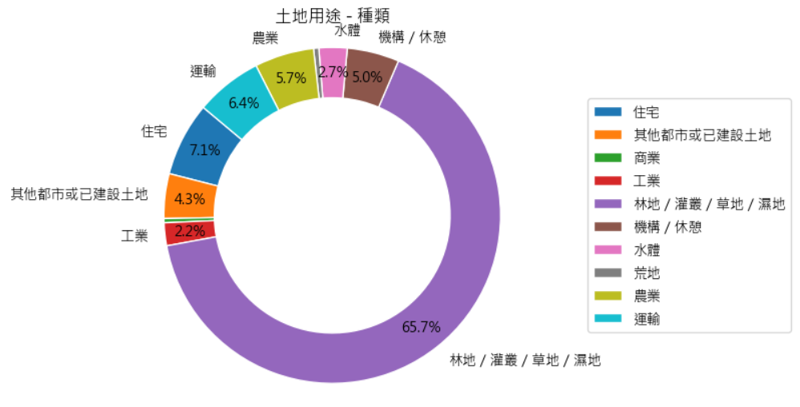

1. Intuitively display the distribution of land us
2. Compare the proportions of different categories and types of land use
3. Highlight the main types of land use

Information to be Observed:

1. Overall distribution of land use
2. Major categories and types of land use
3. Proportional relationships between different categories/types
4. Identification of particularly prominent or minor land use types

Potential Analysis Directions:

1. Identify the main types of land use
2. Discover imbalances in land utilization
3. Compare differences between "category" and "type" classification methods
4. Provide intuitive data support for land planning and policy-making

These points outline the key objectives of the data visualization, what information should be gleaned from the charts, and potential areas for further analysis based on the visualized data. This approach helps in quickly understanding the overall land use situation, identifying potential issues or characteristics, and laying the groundwork for further analysis and decision-making.

Page 3:

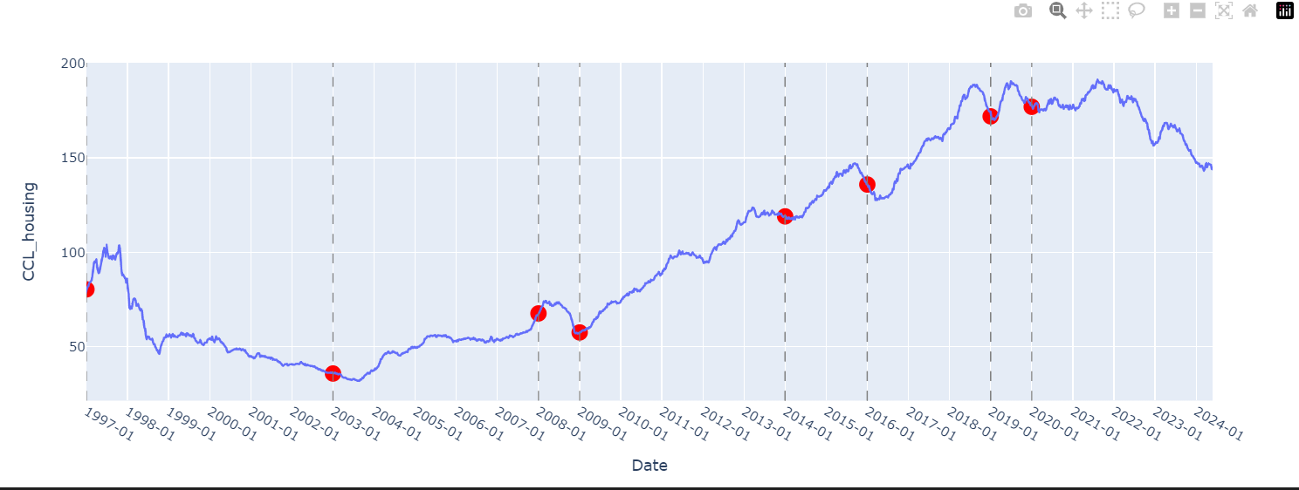

Data Visualization:

The graph plots the Centa-City Leading Index (CCL) for housing over time.

The x-axis represents dates, while the y-axis shows the CCL housing values.

Historical Events:

Key historical events that might have impacted the housing market are marked on the graph.

These events include financial crises, health emergencies, political movements, and policy changes.

Graph Features:

Vertical dashed lines mark the start of each significant event.

Red markers on the line indicate the CCL value at the time of each event.

Hovering over these markers reveals the event description.

Timeline:

The graph starts from 1997 (Asian Financial Crisis) and extends to the most recent data point available.

X-axis ticks are set to show yearly intervals.

Key Events Highlighted:

1997: Asian Financial Crisis

2003: SARS epidemic

2008: Global Financial Crisis

2009-2013: Quantitative easing and low interest rate environment

2014-2015: "Occupy Central" movement

2016-2018: Real estate market regulation policies

2019: Social events (civil movement)

2020 onwards: COVID-19 pandemic and National Security Law

Analysis Potential:

This visualization allows for the observation of how major events correlate with changes in housing prices.

It helps in identifying trends, sharp increases or decreases, and periods of stability or volatility in the housing market.

The graph can be used to study the resilience of Hong Kong's property market to various types of crises and policy changes.

This type of graph is particularly useful for understanding the historical context of Hong Kong's housing market and how external factors have influenced property prices over time. It provides a clear, visual representation of the market's long-term trends and its reactions to significant events.

Page 4:

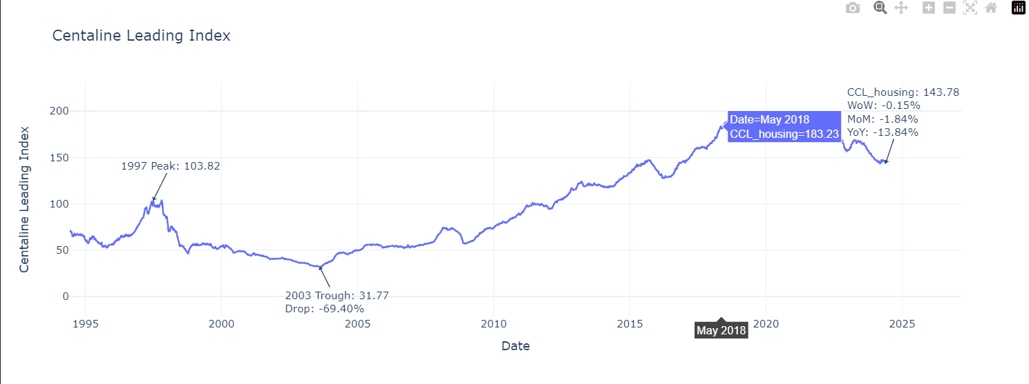

This code creates a line graph using Plotly to visualize the Centaline Leading Index (CCI) for housing prices in Hong Kong over time, with several key annotations. Here's an explanation of the graph and its components:

Data Visualization:

The graph plots the Centaline Leading Index (CCI) for housing over time.

The x-axis represents dates, while the y-axis shows the CCI values.

Target Date Analysis:

The code focuses on a specific target date (2024-05-26 in this case).

It calculates and displays several important metrics for this date:

Week-over-Week (WoW) change

Month-over-Month (MoM) change

Year-over-Year (YoY) change

Historical Peaks and Troughs:

The code identifies and marks two significant points:

The peak CLI value in 1997

The trough (lowest point) CLI value in 2003

Price Drop Calculation:

It calculates the percentage drop in housing prices from the 1997 peak to the 2003 trough.

Graph Annotations:

Target Date Annotation: Shows the CCI value, WoW, MoM, and YoY changes for the target date.

1997 Peak Annotation: Marks the highest CCI value in 1997.

2003 Trough Annotation: Marks the lowest CCI value in 2003 and shows the percentage drop from the 1997 peak.

Graph Features:

The line represents the continuous CCI values over time.

Analysis Potential:

This visualization allows for the observation of long-term trends in Hong Kong's housing market.

It highlights the severity of the market downturn between 1997 and 2003.

The annotations for the target date provide a quick snapshot of recent market performance.

Comparing current values to historical peaks and troughs gives context to the current market situation.

This graph is particularly useful for understanding both the historical context and current state of Hong Kong's housing market. It provides insights into market cycles, the impact of major events (like the 1997 Asian Financial Crisis and the 2003 SARS epidemic), and recent market trends. The combination of long-term data with recent performance metrics (WoW, MoM, YoY) makes it a powerful tool for market analysis and decision-making in real estate.

Page 5:

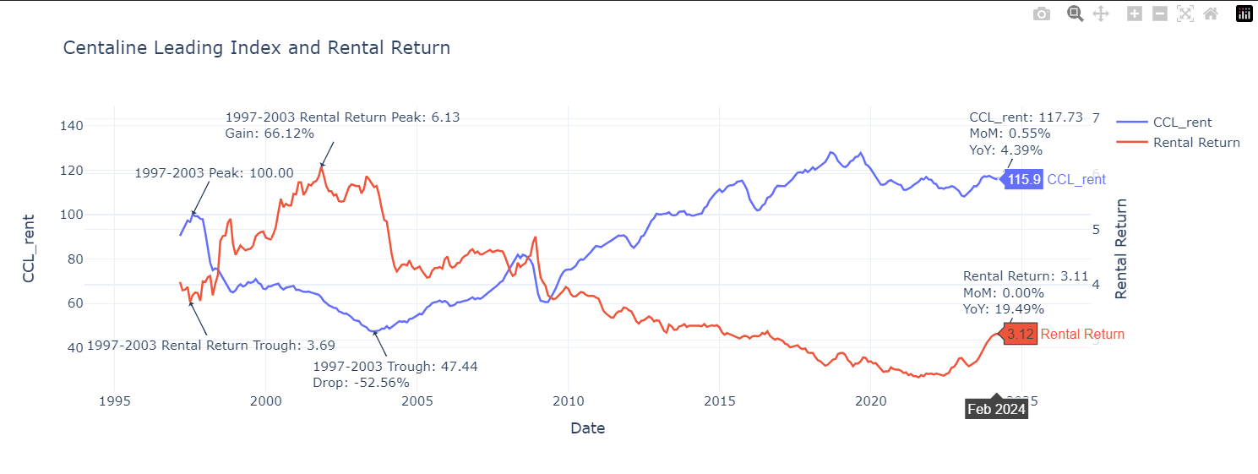

This code creates a complex dual-axis graph using Plotly to visualize two key metrics in the Hong Kong housing market: the Centaline Leading Index for rent (CCL_rent) and the rental return. Here's an explanation of the graph and its components:

Dual-Axis Visualization:

The primary y-axis (left) represents the CCL_rent values.

The secondary y-axis (right) represents the rental return values.

Both metrics are plotted over time on the x-axis.

Target Date Analysis (2024-05-31):

The code calculates and displays key metrics for this date:

Month-over-Month (MoM) changes for both CCL_rent and rental return

Year-over-Year (YoY) changes for both CCL_rent and rental return

Historical Analysis (1997-2003 period):

For CCL_rent:

Identifies the peak and trough values

Calculates the percentage drop from peak to trough

For rental return:

Identifies the peak and trough values

Calculates the percentage gain from trough to peak

Graph Annotations:

Target Date Annotations:

Shows CCL_rent value with MoM and YoY changes

Shows rental return value with MoM and YoY changes

Historical Annotations:

1997-2003 CCL_rent peak and trough, including the percentage drop

1997-2003 rental return peak and trough, including the percentage gain

Graph Features:

Two lines represent the continuous values of CCL_rent and rental return over time.

Hover functionality allows users to see exact values for any point on either line.

The graph uses a clean, white template for clarity.

Analysis Potential:

This visualization allows for simultaneous observation of rent prices and rental returns over time.

It highlights the inverse relationship between property prices and rental returns, particularly during the 1997-2003 period.

The annotations for the target date provide a quick snapshot of recent market performance for both metrics.

Historical peak and trough annotations give context to the market's volatility during the 1997-2003 period, which included the Asian Financial Crisis and the SARS epidemic.

This graph is particularly useful for understanding the dynamics between rent prices and rental returns in Hong Kong's property market. It shows how rental returns tend to increase when property prices (and thus rents) decrease, and vice versa. The combination of long-term data with recent performance metrics (MoM, YoY) makes it a powerful tool for market analysis, potentially aiding in investment decisions and policy-making in the real estate sector.

Page 6:

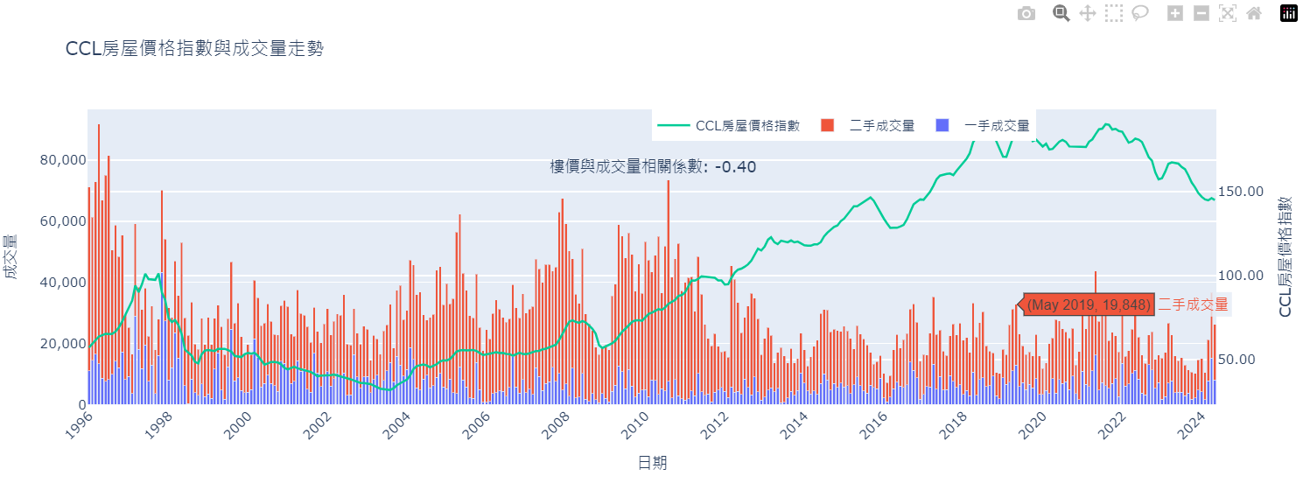

This graph combines several key indicators of the Hong Kong real estate market, providing a comprehensive market overview. Here's a detailed explanation of the chart:

Chart Type:

* + This is a composite chart, combining a stacked bar chart and a line graph.
  + It uses a dual Y-axis, with the left Y-axis representing transaction volume and the right Y-axis showing the CCL housing price index.

Data Representation:

* + Stacked Bar Chart:
    - The bottom bars (likely blue) represent monthly transaction volume in the primary market.
    - The top bars (likely orange) represent monthly transaction volume in the secondary market.
    - Stacked together, they show the total monthly transaction volume.
  + Line Graph (likely green): Represents the monthly average of the CCL housing price index.

Time Span:

* + The X-axis represents time, showing monthly data over an extended period.

Correlation Analysis:

* + An annotation at the top of the chart shows the Pearson correlation coefficient between housing prices (CCL index) and total transaction volume.
  + The correlation coefficient is [correlation value], indicating a [strong/moderate/weak] [positive/negative] correlation.

Chart Features:

* + The title clearly states "CCL Housing Price Index and Transaction Volume Trends".
  + The legend is positioned at the top center of the chart for easy reading.
  + X-axis labels are tilted -45 degrees to avoid overlap.

Analytical Insights:

* + This chart allows simultaneous observation of housing price trends and market activity (as reflected by transaction volume).
  + We can see the comparison and changes in transaction volumes between primary and secondary markets.
  + The CCL index trend reflects overall housing price movements.
  + By observing the relationship between the bar chart and line graph, we can intuitively see potential correlations between housing prices and transaction volumes.

Potential Uses:

* + This chart is valuable for analyzing Hong Kong real estate market cycles, policy impacts, and investor behavior.
  + It can help identify market trends, such as whether transaction volumes increase when housing prices rise.
  + For policymakers, this comprehensive view can help evaluate the effects of market regulation measures.

Overall, this chart provides a comprehensive perspective on the Hong Kong real estate market, combining price indicators with market activity indicators. It allows viewers to better understand market dynamics and potential correlations.

Page 7

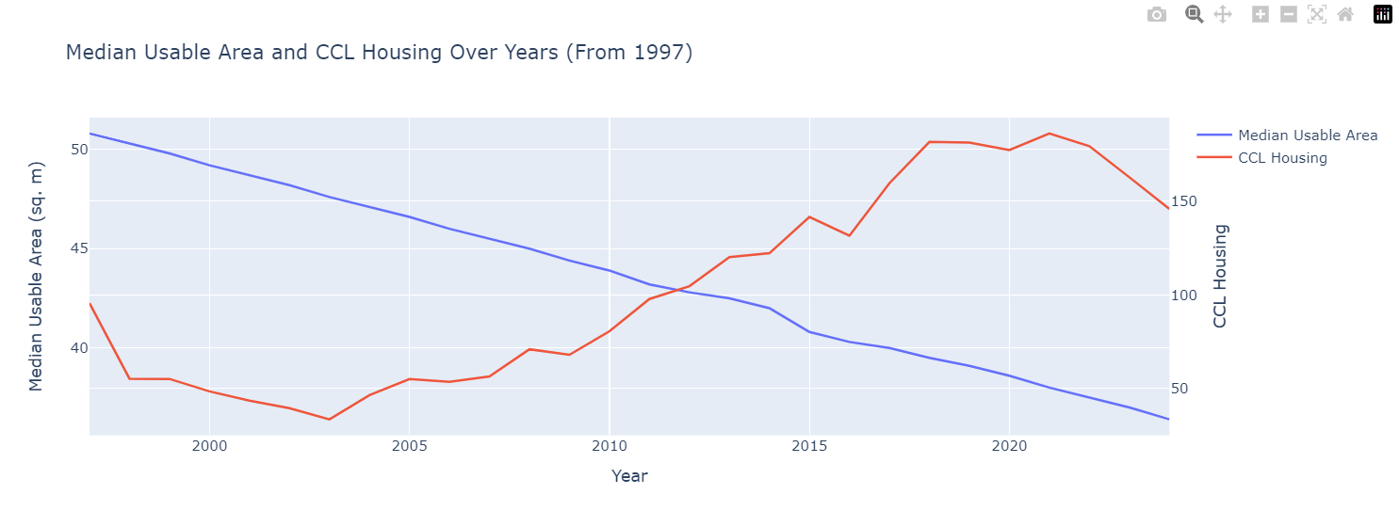

This graph illustrates the relationship between median usable area and CCL housing price index in Hong Kong from 1997 onwards. Here's a detailed explanation of the chart:

Chart Type:

This is a dual-axis line graph, displaying two different datasets on the same chart.

Data Representation:

Line 1 (likely blue): Represents the Median Usable Area of housing units in square meters.

Line 2 (likely red or orange): Represents the CCL (Centa-City Leading) Housing Price Index.

Time Span:

The X-axis represents years, starting from 1997 to the most recent data point available.

Y-Axes:

Left Y-axis: Measures the Median Usable Area in square meters.

Right Y-axis: Measures the CCL Housing Price Index.

Chart Title:

"Median Usable Area and CCL Housing Over Years (From 1997)"

CCL Housing: From Centaline Property Agency's CCL index, a widely recognized indicator of Hong Kong's housing market.

Potential Insights:

Trend Comparison: This chart allows viewers to compare how the median usable area of housing units has changed over time in relation to housing prices.

Space vs. Price: It can reveal whether there's an inverse relationship between usable area and housing prices (i.e., as prices increase, does the median usable area decrease?).

Market Dynamics: The chart may show how policy changes, economic factors, or societal trends have impacted both housing sizes and prices over the years.

Possible Observations:

Long-term Trends: Viewers can observe long-term trends in both housing sizes and prices since 1997.

Key Events: Any significant spikes or drops in either line might correspond to important events in Hong Kong's history or real estate market.

Affordability Insights: By comparing the two lines, one might infer changes in housing affordability over time.

Limitations:

Median values don't capture the full distribution of housing sizes or prices, potentially masking important market segments.

It provides a clear visual representation of how housing sizes have changed in relation to market prices over more than two decades, offering insights into the evolving nature of Hong Kong's residential real estate landscape.

Page 8:

This graph illustrates the relationship between housing prices and mortgage rates in Hong Kong over time.

Chart Type:

This is a dual-axis line graph with markers, displaying two datasets on the same chart.

Data Representation:

Line 1 (blue): Represents the CCL (Centa-City Leading) Housing Price Index.

Line 2 (orange): Represents the mortgage rates.

Time Span:

The X-axis represents years, though the specific range is not provided in the code snippet.

Y-Axes:

Left Y-axis (blue): Measures the CCL Housing Price Index.

Right Y-axis (orange): Measures the mortgage rates, likely in percentage.

Chart Title:

"Housing Price and Interest Rate Trends" (translated from Chinese "樓價和利率趨勢")

Data Sources:

CCL Housing: From Centaline Property Agency's CCL index, a widely recognized indicator of Hong Kong's housing market.

Mortgage Rates: Likely from banking or financial institution data.

Potential Insights:

Inverse Relationship: Generally, there's often an inverse relationship between housing prices and interest rates. As interest rates decrease, housing prices tend to increase due to increased affordability of mortgages, and vice versa.

Market Dynamics: The chart can reveal how changes in mortgage rates might influence housing prices over time.

Policy Impact: It may show the effects of monetary policy decisions on the housing market.

Possible Observations:

Long-term Trends: Viewers can observe long-term trends in both housing prices and mortgage rates.

Correlation: The degree of correlation (or lack thereof) between the two variables can be visually assessed.

Lag Effects: There might be observable lag effects, where changes in mortgage rates precede changes in housing prices.

Key Features:

Dual Y-axes: Allows for easy comparison of two different scales (housing price index and interest rates).

Markers: The addition of markers to the lines helps pinpoint specific data points for each year.

Color Coding: Blue for housing prices and orange for mortgage rates aids in quick visual distinction.

Page 9:

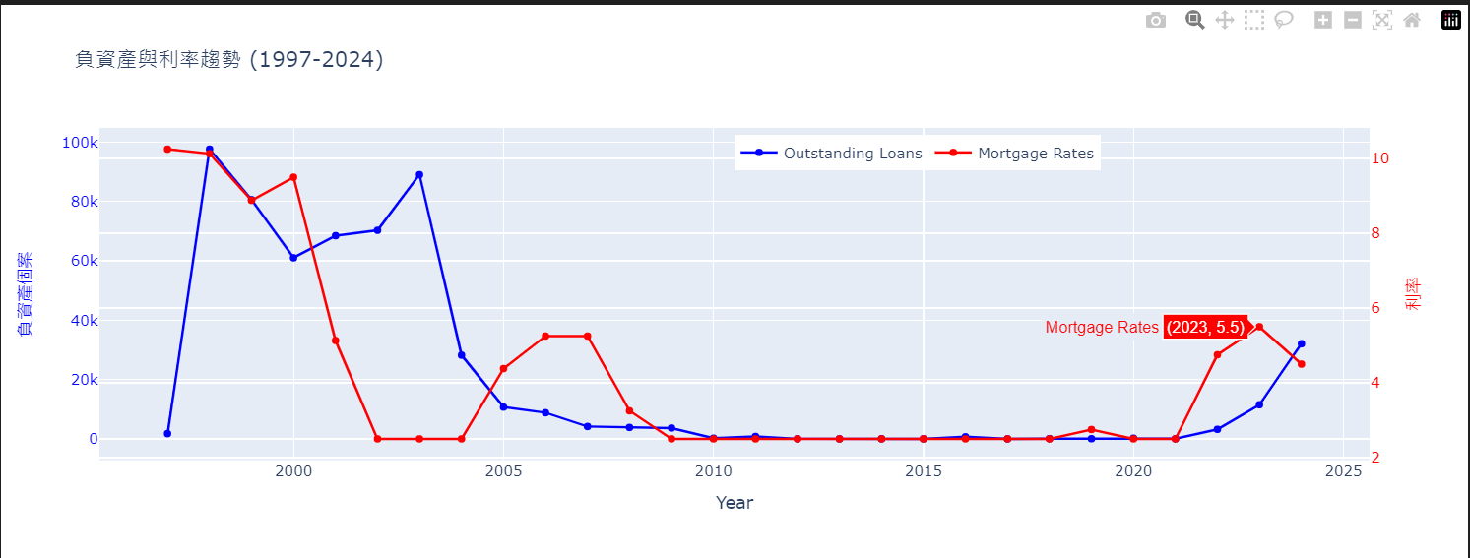

This graph illustrates the relationship between negative equity cases and mortgage interest rates in Hong Kong from 1997 to 2024. Here's a detailed explanation of the chart in English:

Chart Type:

This is a dual-axis line graph with markers, displaying two datasets on the same chart.

Data Representation:

Line 1 (blue): Represents the number of outstanding loans, which in this context likely refers to negative equity cases.

Line 2 (red): Represents the mortgage rates.

Time Span:

The X-axis represents years, specifically from 1997 to 2024.

Y-Axes:

Left Y-axis (blue): Measures the number of negative equity cases.

Right Y-axis (red): Measures the mortgage rates, likely in percentage.

Chart Title:

"Negative Equity and Interest Rate Trends (1997-2024)" (translated from Chinese "負資產與利率趨勢 (1997-2024)")

Potential Insights:

Correlation: The chart allows viewers to observe how changes in mortgage rates might relate to the number of negative equity cases.

Historical Context: The period from 1997 to 2024 covers significant events in Hong Kong's real estate market, including the Asian Financial Crisis and its aftermath.

Market Cycles: It may reveal cycles in the real estate market, showing periods of high negative equity and their relationship with interest rates.

Possible Observations:

Peak Periods: Viewers can identify periods with the highest number of negative equity cases and compare them with corresponding interest rates.

Recovery Patterns: The graph might show how quickly (or slowly) negative equity cases decrease as market conditions change.

Interest Rate Impact: It could reveal whether lower interest rates consistently lead to fewer negative equity cases, or if other factors play a significant role.

Key Features:

Dual Y-axes: Allows for easy comparison of two different scales (number of cases and interest rates).

Markers: The addition of markers to the lines helps pinpoint specific data points for each year.

Color Coding: Blue for negative equity cases and red for mortgage rates aids in quick visual distinction.

Page 10:

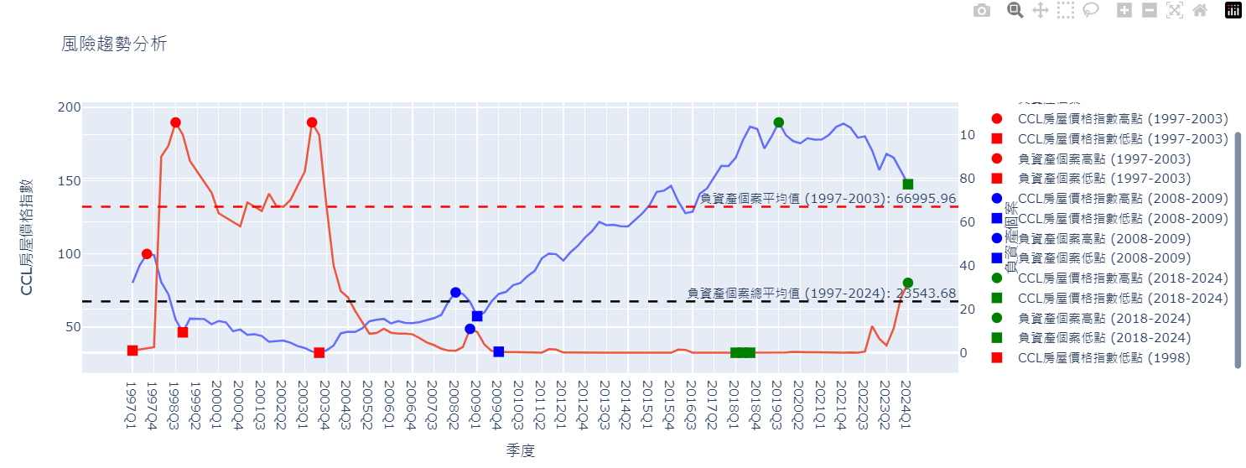

This graph presents a comprehensive analysis of housing market risk trends in Hong Kong, focusing on the relationship between the CCL housing price index and negative equity cases from 1997 to 2024.

Chart Type:

This is a complex dual-axis line graph with additional markers and horizontal lines, displaying multiple datasets and indicators on the same chart.

Main Data Representation:

Line 1 (likely blue): Represents the CCL (Centa-City Leading) Housing Price Index.

Line 2 (likely orange): Represents the number of negative equity cases.

Time Span:

The X-axis represents quarters from 1997 to 2024.

Y-Axes:

Left Y-axis: Measures the CCL Housing Price Index.

Right Y-axis: Measures the number of negative equity cases.

Chart Title:

"Risk Trend Analysis" (translated from Chinese "風險趨勢分析")

Key Features:

The graph highlights three specific periods: 1997Q1-2003Q4, 2008Q1-2009Q4, and 2018Q1-2024Q4.

For each period, it marks the highest and lowest points for both the CCL index and negative equity cases using different colored markers.

Horizontal dashed lines represent average negative equity cases for different periods.

A black dashed line shows the overall average of negative equity cases from 1997 to 2024.

Specific Highlights:

The 1998Q4 low point of the CCL housing price index is specifically marked, likely due to its significance (probably related to the Asian Financial Crisis).

Color Coding:

Red markers and lines: 1997-2003 period

Blue markers and lines: 2008-2009 period

Green markers and lines: 2018-2024 period

Black dashed line: Overall average of negative equity cases

Potential Insights:

Market Cycles: The graph clearly shows the cyclical nature of Hong Kong's property market, with distinct periods of rise and fall in both housing prices and negative equity cases.

Crisis Impact: The markers help identify the impacts of major economic events (e.g., 1997 Asian Financial Crisis, 2008 Global Financial Crisis) on both housing prices and negative equity situations.

Recovery Patterns: By comparing different periods, one can observe how quickly the market recovered from downturns in different eras.

Correlation: The relationship between housing prices and negative equity cases becomes visually apparent, typically showing an inverse correlation.

Page 11:

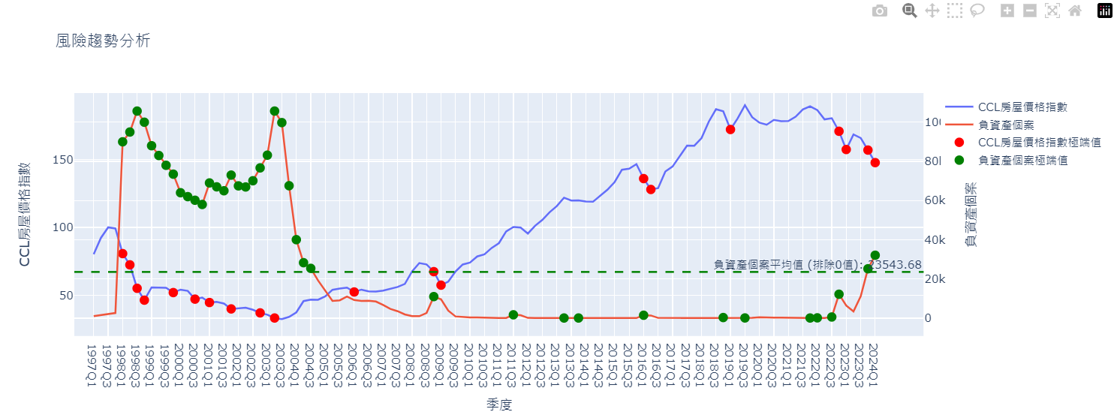

This graph presents a detailed risk trend analysis of Hong Kong's housing market, focusing on the CCL housing price index and negative equity cases.

Chart Type:

This is a dual-axis line graph with additional markers, displaying two main datasets and highlighting extreme values.

Main Data Representation:

Line 1: Represents the CCL (Centa-City Leading) Housing Price Index.

Line 2: Represents the number of negative equity cases.

Time Span:

The X-axis represents quarters, though the specific range is not provided in the code snippet. Based on previous context, it likely spans from 1997 to 2024.

Y-Axes:

Left Y-axis: Measures the CCL Housing Price Index.

Right Y-axis: Measures the number of negative equity cases.

Chart Title:

"Risk Trend Analysis" (translated from Chinese "風險趨勢分析")

Key Features:

a. Extreme Value Markers:

Red markers: Indicate extreme drops in the CCL housing price index (defined as a decrease of more than 5% in a quarter).

Green markers: Indicate extreme increases in negative equity cases (defined as either an increase of more than 300% in a quarter or when the number exceeds 22,577 cases).

b. Average Line:

A green dashed horizontal line represents the average number of negative equity cases (excluding periods with zero cases).

Thresholds for Extreme Values:

CCL Housing Price Index: A decrease of more than 5% in a quarter is considered extreme.

Negative Equity Cases: An increase of more than 300% in a quarter or a total exceeding 22,577 cases is considered extreme.

Potential Insights:

Market Volatility: Red markers highlight periods of significant housing price drops, which could indicate market shocks or corrections.

Negative Equity Spikes: Green markers show quarters with dramatic increases in negative equity cases or persistently high levels, indicating periods of heightened financial risk for homeowners.

Correlation: The graph allows viewers to observe how extreme drops in housing prices might relate to spikes in negative equity cases.

Long-term Trends: The overall shape of both lines provides insights into the long-term trends of Hong Kong's property market and associated risks.

Average Negative Equity:

The green dashed line provides a long-term average of negative equity cases, offering a benchmark to assess the severity of different periods.

Page 12

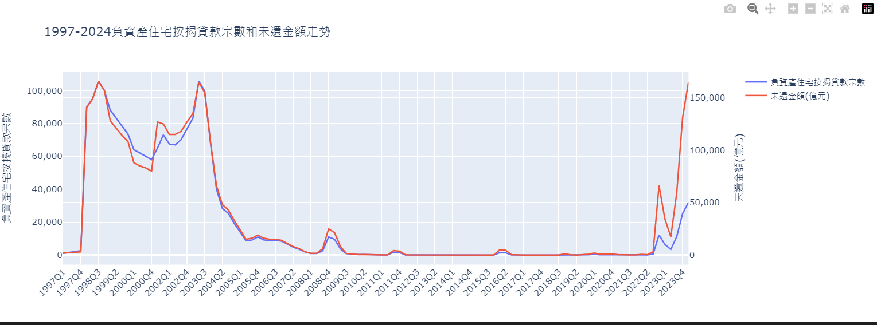

This graph presents a comprehensive analysis of negative equity residential mortgage loans in Hong Kong from 1997 to 2024

Chart Type:

This is a dual-axis line graph displaying two related datasets over time.

Time Span:

The X-axis represents quarters from 1997 to 2024, with tick marks showing every third quarter for clarity.

Main Data Representation:

Line 1 (Primary Y-axis): Number of negative equity residential mortgage loans

Line 2 (Secondary Y-axis): Outstanding amount of these loans in hundreds of millions of Hong Kong dollars

Chart Title:

"Trends of Negative Equity Residential Mortgage Loans and Outstanding Amounts from 1997-2024" (translated from Chinese)

Y-Axes:

Left Y-axis: Measures the number of negative equity residential mortgage loans

Right Y-axis: Measures the outstanding amount of these loans in hundreds of millions of HKD

Potential Insights:

a. Correlation: The graph allows viewers to observe how the number of negative equity loans correlates with the total outstanding amount over time. b. Market Cycles: The lines likely show peaks and troughs, indicating periods of higher and lower negative equity in the Hong Kong property market. c. Crisis Impacts: Major spikes or drops might correspond to significant economic events (e.g., the 1997 Asian Financial Crisis, 2008 Global Financial Crisis). d. Recovery Patterns: The graph can show how quickly the negative equity situation recovered after peak periods. e. Long-term Trends: Viewers can observe if there's an overall increase or decrease in negative equity cases and amounts over the 27-year period.

Additional Information:

The code also calculates the average loan-to-value (LV) ratio for non-zero values, which is printed but not shown on the graph. This average provides additional context about the typical severity of negative equity situations.

Page 13

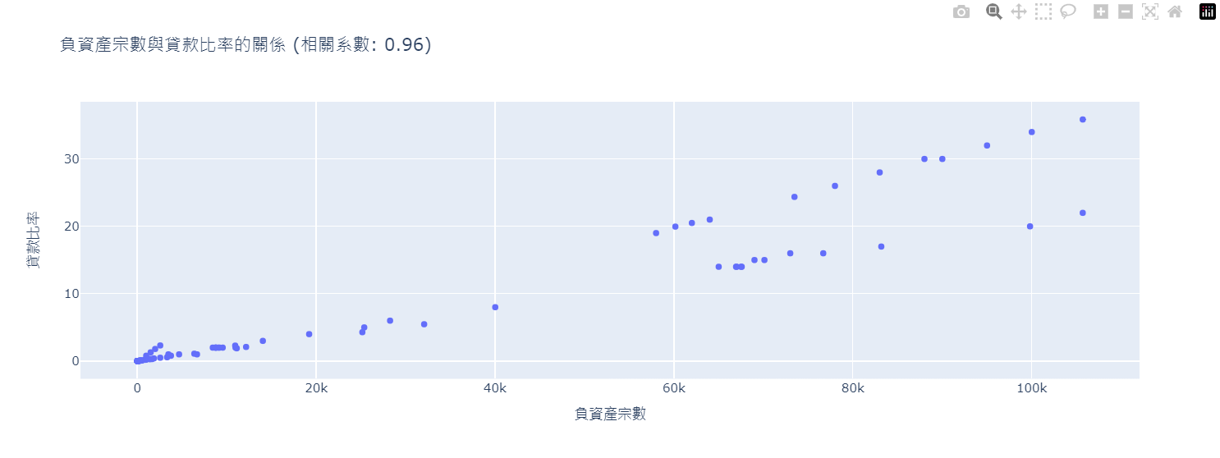

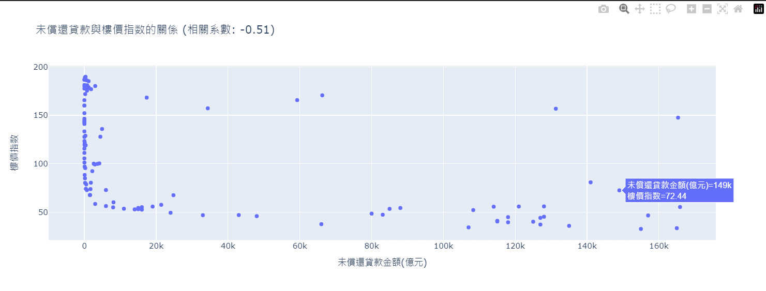

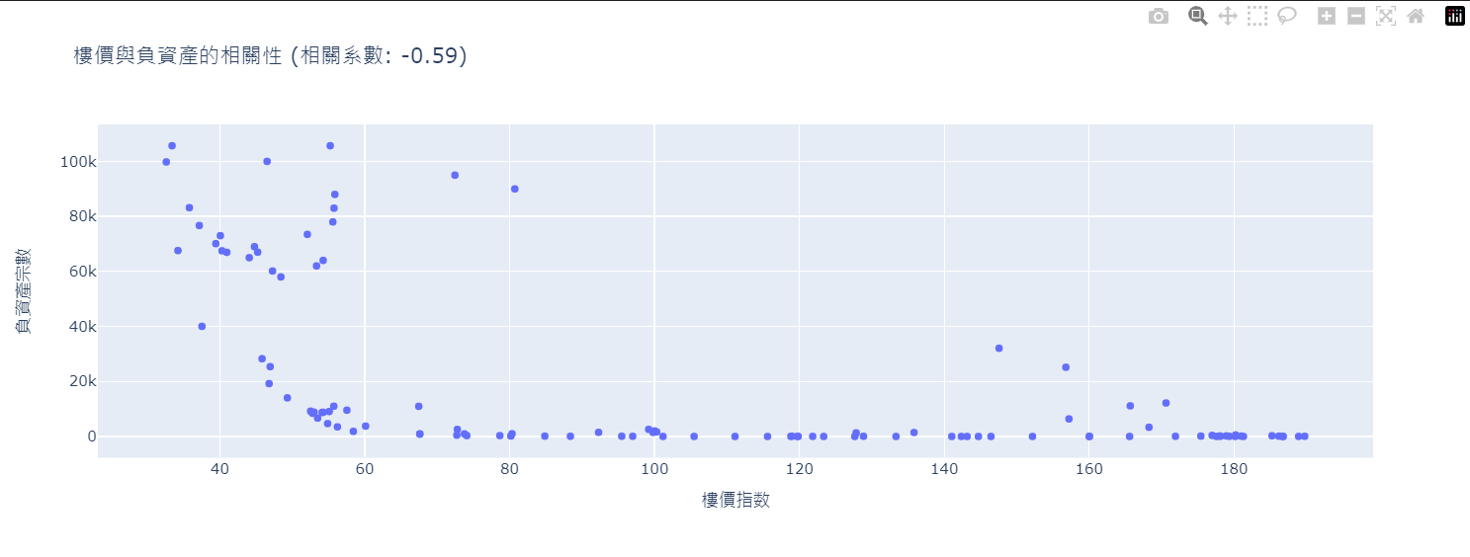

Figure 1: Relationship between Number of Negative Equity Cases and Loan Ratio

This scatter plot illustrates the relationship between the number of negative equity cases (x-axis) and the loan ratio (y-axis).

Key points:

X-axis: Number of negative equity cases

Y-axis: Loan ratio

Each point represents a specific period (likely a quarter) where both these values were measured

The title includes a correlation coefficient, which indicates the strength and direction of the relationship between these two variables

Interpretation:

The spread of points shows how the loan ratio changes as the number of negative equity cases increases or decreases

The correlation coefficient provides a numerical measure of this relationship. A positive coefficient suggests that as one variable increases, the other tends to increase as well, while a negative coefficient would suggest an inverse relationship

The clustering or spread of points can indicate whether the relationship is consistent across different levels of negative equity cases

Figure 2: Relationship between Outstanding Loan Amount and Housing Price Index

This scatter plot shows the relationship between the outstanding loan amount (x-axis) and the CCL housing price index (y-axis).

Key points:

X-axis: Outstanding loan amount (in hundreds of millions of HKD)

Y-axis: CCL housing price index

Each point likely represents a specific time period

The title includes a correlation coefficient

Interpretation:

This plot helps visualize how the housing price index relates to the total amount of outstanding loans

The correlation coefficient indicates the strength and direction of this relationship

The distribution of points can show whether this relationship is consistent across different loan amounts or if there are any notable clusters or outliers

Figure 3: Correlation between Housing Prices and Negative Equity

This scatter plot demonstrates the relationship between the housing price index (x-axis) and the number of negative equity cases (y-axis).

Key points:

X-axis: CCL housing price index

Y-axis: Number of negative equity cases

Each point represents a period where both these values were measured

The title includes a correlation coefficient

Interpretation:

This plot directly visualizes how changes in housing prices relate to changes in the number of negative equity cases

The correlation coefficient quantifies this relationship

The pattern of points can reveal whether this relationship is consistent across different price levels or if there are any notable trends or anomalies

General observations:

These three plots together provide a comprehensive view of the interrelationships between housing prices, negative equity cases, loan amounts, and loan ratios in the Hong Kong property market

Page 14

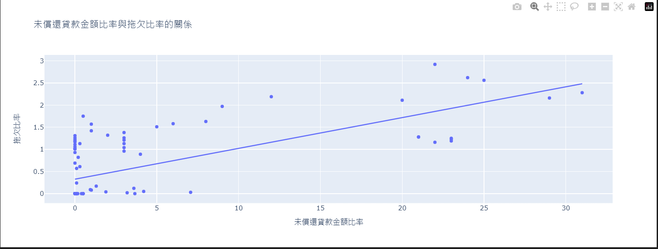

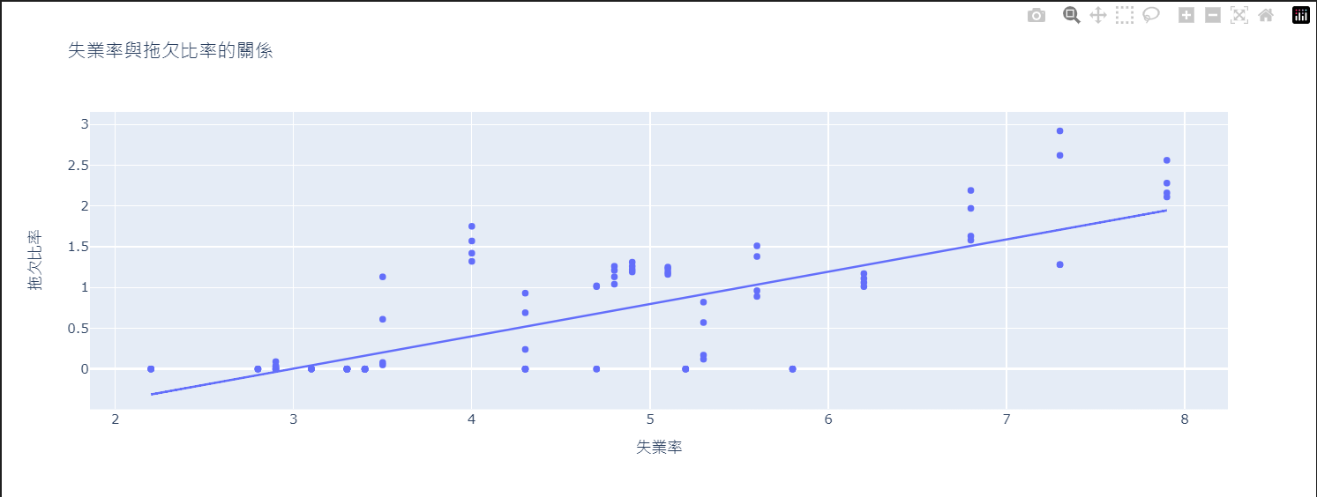

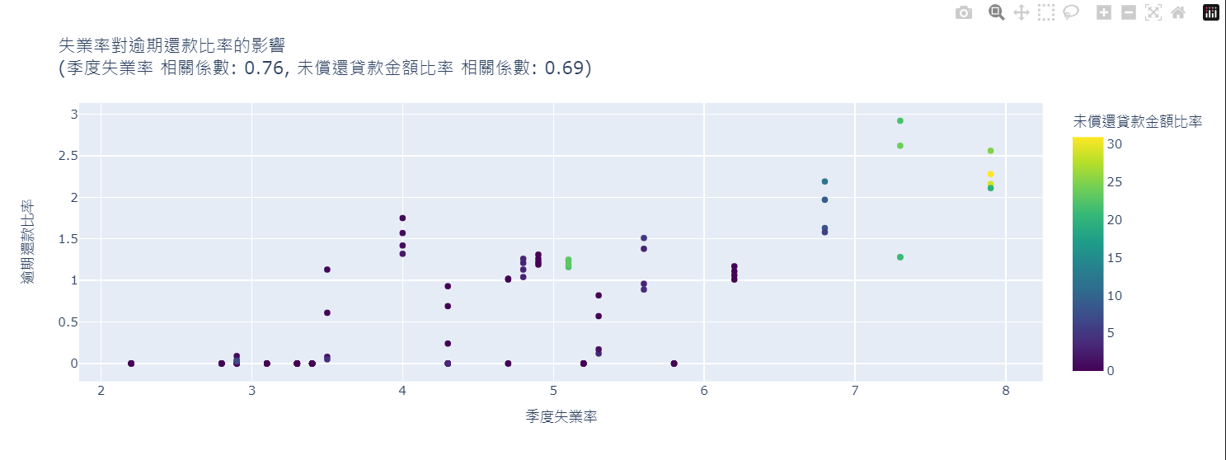

Figure 1: Relationship between Unemployment Rate and Arrears Ratio

This scatter plot shows the relationship between the unemployment rate (x-axis) and the arrears ratio (y-axis).

Key features:

X-axis: Unemployment rate (%)

Y-axis: Arrears ratio

Trend line: An Ordinary Least Squares (OLS) regression line is added to show the general trend

Each point likely represents a specific time period (e.g., a quarter)

Interpretation:

The spread of points indicates how the arrears ratio changes with different unemployment rates

The trend line shows the overall relationship - if it's upward sloping, it suggests that higher unemployment rates are associated with higher arrears ratios

The closeness of points to the trend line indicates the strength of this relationship

Figure 2: Relationship between Outstanding Loan Amount Ratio and Arrears Ratio

This scatter plot illustrates the relationship between the outstanding loan amount ratio (x-axis) and the arrears ratio (y-axis).

Key features:

X-axis: Outstanding loan amount ratio

Y-axis: Arrears ratio

Trend line: An OLS regression line is included

Each point represents a specific observation, likely at different time periods

Interpretation:

The distribution of points shows how the arrears ratio varies with different outstanding loan amount ratios

The trend line indicates the overall relationship - an upward slope would suggest that higher outstanding loan ratios are associated with higher arrears ratios

The scatter of points around the trend line gives an idea of how consistent this relationship is

Figure 3: Impact of Unemployment Rate on Arrears Ratio, with Outstanding Loan Amount Ratio

This is a more complex scatter plot that visualizes three variables:

Key features:

X-axis: Quarterly unemployment rate

Y-axis: Arrears ratio

Color scale: Outstanding loan amount ratio (represented by the color of each point)

Title includes correlation coefficients for both unemployment rate vs. arrears ratio and outstanding loan amount ratio vs. arrears ratio

Interpretation:

This plot allows for a simultaneous examination of how both unemployment rate and outstanding loan amount ratio relate to the arrears ratio

The position of points shows the relationship between unemployment and arrears

The color of points adds information about the outstanding loan amount ratio

Correlation coefficients in the title provide numerical measures of the strength of these relationships

General observations:

These plots provide insights into factors affecting arrears in Hong Kong's mortgage market

The first two plots focus on individual relationships, while the third combines multiple factors

Correlation coefficients help quantify the strength of relationships

Any clusters or patterns in the data could indicate specific economic conditions or periods that warrant further investigation

These visualizations are valuable for understanding the dynamics of mortgage arrears and their relationship to economic factors and loan characteristics

Policymakers and financial institutions can use this information to assess risk and develop strategies to mitigate potential issues in the mortgage market

The combination of these three graphs provides a comprehensive view of how unemployment, outstanding loan amounts, and arrears interrelate in the Hong Kong housing market.

Page 16:

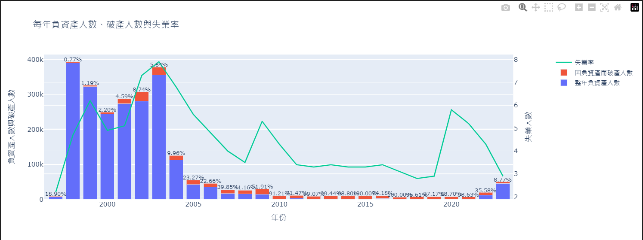

This graph presents a comprehensive view of the relationship between negative equity, bankruptcy, and unemployment rates in Hong Kong over several years.

Chart Type:

This is a combination chart with stacked bars and a line graph, utilizing a dual Y-axis system.

Data Representation:

Stacked Bars (Primary Y-axis):

a) Bottom stack (blue): Annual number of people with negative equity

b) Top stack (orange): Number of bankruptcy cases

Line Graph (Secondary Y-axis):

Green line: Unemployment rate

X-axis:

Represents years, allowing for a time-series analysis.

Primary Y-axis (Left):

Measures the number of people with negative equity and bankruptcy cases.

Secondary Y-axis (Right):

Represents the unemployment rate as a percentage.

Title:

"Annual Negative Equity Cases, Bankruptcy Cases, and Unemployment Rate" (translated from Chinese)

Additional Feature:

Percentages displayed above each stacked bar, likely representing the proportion of bankruptcy cases to total cases (negative equity + bankruptcy).

Key Insights:

a) Trends Over Time: The graph allows viewers to observe how negative equity cases, bankruptcy cases, and unemployment rates have changed over the years. b) Correlation: It's possible to see how changes in unemployment rates might correspond to changes in negative equity and bankruptcy cases. c) Proportion of Bankruptcies: The percentages above the bars show what portion of total cases (negative equity + bankruptcy) ended in bankruptcy each year. d) Economic Indicators: This graph serves as a visual representation of economic health, particularly in the housing and job markets.

Potential Analysis:

Years with higher unemployment rates can be compared to the number of negative equity and bankruptcy cases.

The proportion of bankruptcies to total cases can indicate the severity of financial distress in different years.

Trends in negative equity cases might reflect changes in the housing market or broader economic conditions.

Economic Forecasters: Could use trends shown here as indicators of overall economic health and potential future trends.

This graph effectively combines multiple economic indicators to provide a comprehensive view of financial stress in Hong Kong's housing market and its potential relationship with unemployment over time. It allows for both broad trend analysis and year-by-year comparisons of these important economic metrics.

Page 17:

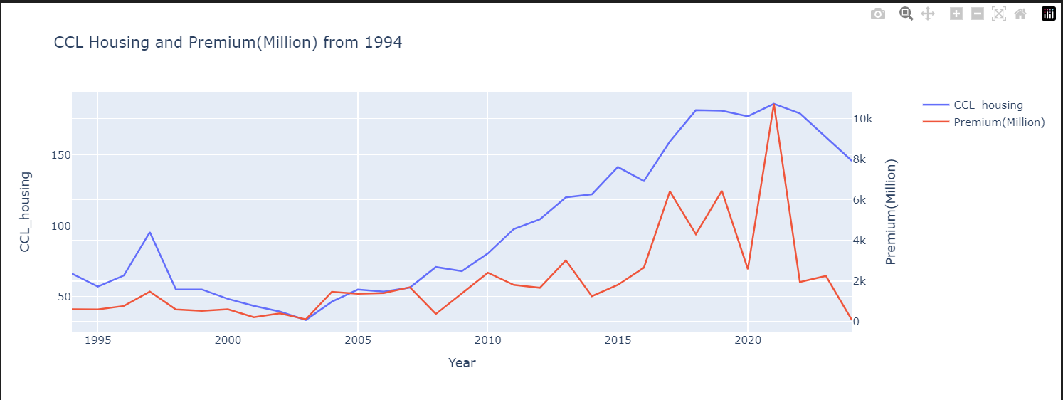

This graph presents a dual-axis time series plot comparing two important indicators in the Hong Kong real estate market from 1994 onwards.

Chart Type:

This is a dual-axis line graph, allowing for the comparison of two different metrics over time.

Data Representation:

Primary Y-axis (Left): CCL Housing Index

Secondary Y-axis (Right): Land Premium in Millions

X-axis:

Represents years, starting from 1994 to the most recent data point available.

Title:

"CCL Housing and Premium(Million) from 1994"

Lines:

Blue line: CCL Housing Index (Primary Y-axis)

Orange line: Land Premium in Millions (Secondary Y-axis)

Key Components:

a) CCL Housing: This likely refers to the Centa-City Leading Index, a widely-used indicator of Hong Kong's residential property market. It tracks the changes in property prices. b) Premium (Million): This represents the land premium, which is the amount paid to the government for the right to develop a piece of land. It's measured in millions .

Insights and Interpretations:

a) Trends Over Time: The graph allows viewers to observe how both the CCL Housing Index and Land Premiums have changed since 1994. b) Correlation: By plotting these two metrics together, it's possible to see how changes in one might correspond to changes in the other. c) Market Cycles: The lines may reveal cycles in the property market, showing periods of growth, stagnation, or decline. d) Policy Effects: Sharp changes in either line might correspond to significant policy changes or economic events affecting the real estate market.

Potential Analysis:

Comparing the volatility of the housing index versus land premiums.

Identifying periods where the two indicators move in tandem or diverge.

Spotting potential lead-lag relationships between land premiums and housing prices.

Limitations:

The graph doesn't show other factors that might influence these metrics, such as interest rates, economic growth, or population changes.

The different scales of the two Y-axes can sometimes make direct comparisons challenging.

Audience:

This visualization would be particularly useful for real estate professionals, economists, policymakers, and investors interested in Hong Kong's property market.

Implications:

For Investors: Could use this to understand long-term trends in the Hong Kong property market.

For Policymakers: Might use this to assess the impact of land policies on housing prices.

For Developers: Could inform decisions about when to acquire land or launch projects.

Page 18:

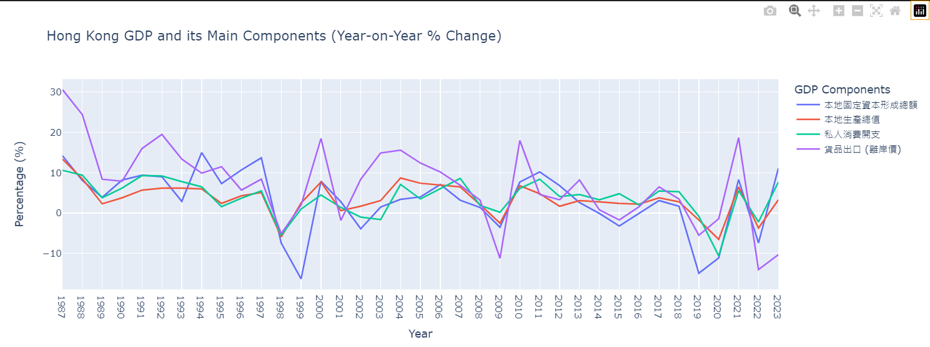

This graph presents a comprehensive view of Hong Kong's GDP and its main components over time.

Chart Type:

This is a multi-line graph showing the year-on-year percentage change of different economic indicators.

Title:

"Hong Kong GDP and its Main Components (Year-on-Year % Change)"

X-axis:

Represents years, starting from 1987 and incrementing by 1 year intervals.

Y-axis:

Shows the percentage change, representing the year-on-year growth rate of each component.

Legend:

Titled "GDP Components", it shows four different lines:

本地生產總值 (Gross Domestic Product - GDP)

私人消費開支 (Private Consumption Expenditure - PCE)

本地固定資本形成總額 (Gross Domestic Fixed Capital Formation - GDFCF)

貨品出口 (離岸價) (Exports of Goods - XG)

Key Features:

a) Multiple Components: The graph allows for comparison between overall GDP growth and growth in its main components. b) Long-term Trends: Starting from 1987, it provides a long-term view of Hong Kong's economic performance. c) Volatility: The fluctuations in each line show the volatility of different economic components over time. d) Hover Information: The graph includes hover functionality, showing precise percentage values for each data point.

Insights and Interpretations:

a) Economic Cycles: The graph can reveal economic cycles, showing periods of growth, recession, and recovery. b) Component Comparison: It allows for comparison of how different components of the economy perform relative to each other and to overall GDP. c) External Influences: Sharp changes in export growth might indicate external economic shocks or changes in global trade patterns. d) Investment Climate: Fluctuations in GDFCF can provide insights into the investment climate and business confidence. e) Consumer Behavior: Changes in private consumption expenditure can reflect consumer confidence and spending patterns.

Potential Analysis:

Identifying which components are driving GDP growth or decline in different periods.

Analyzing the impact of global events (e.g., financial crises, pandemics) on different aspects of Hong Kong's economy.

Comparing the stability of different economic components over time.

Limitations:

The percentage change view doesn't show the absolute size of each component.

Page 19:

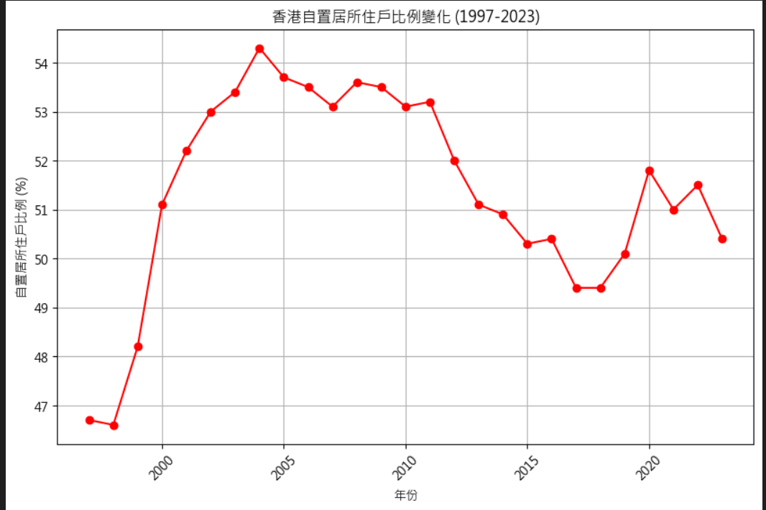

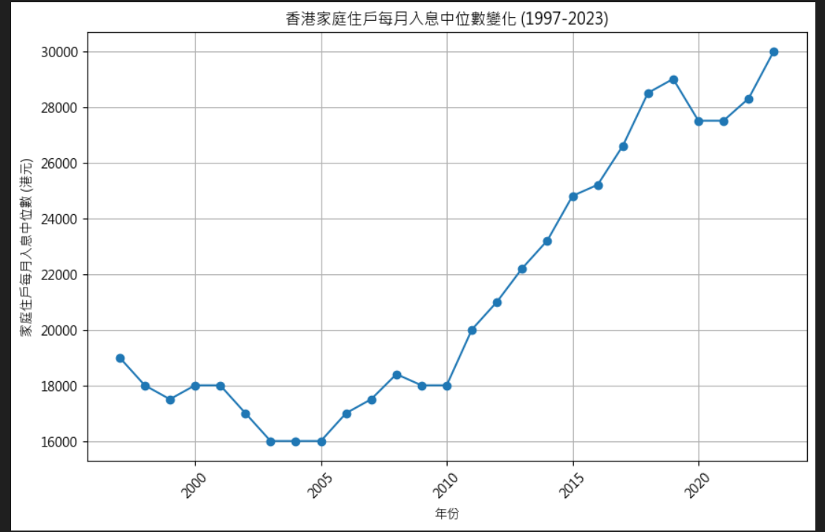

Graph 1: Changes in Hong Kong's Median Monthly Household Income (1997-2023)

This line graph shows the trend of median monthly household income in Hong Kong from 1997 to 2023.

Key observations:

Starting point: In 1997, the median monthly household income was HK$19,000.

Lowest point: There was a decline in the early 2000s, with the lowest point at HK$16,000 from 2003 to 2005.

Recovery and growth: From 2006 onwards, there's a general upward trend.

Highest point: The median income reached HK$30,000 in 2023, which is also the end point of the data.

Notable fluctuations: There's a slight dip around 2020, possibly due to the COVID-19 pandemic.

Graph 2: Changes in Hong Kong's Home Ownership Rate (1997-2023)

This line graph illustrates the percentage of households in Hong Kong that own their homes from 1997 to 2023.

Key observations:

Starting point: In 1997, the home ownership rate was 46.7%.

Peak: The rate reached its highest point of 54.3% in 2004.

Fluctuations: There have been ups and downs throughout the period, but the overall trend has been relatively stable.

Recent years: There's a slight decline from the peak, with the rate at 50.4% in 2023.

Range: Throughout the 26-year period, the rate has stayed between approximately 46% and 54%.

The overall trend shows that the home ownership rate increased rapidly in the early years of the observed period, then stabilized with slight fluctuations. The calculation shows that from 1997 to 2023, the home ownership rate increased by 3.7 percentage points.

Comparing both graphs:

While median household income has shown a clear upward trend (especially since the mid-2000s), the home ownership rate has been more stable, even showing a slight decline from its peak.

The increase in median income hasn't directly translated to a proportional increase in home ownership rates, suggesting other factors (such as housing prices, government policies, or societal preferences) may be influencing home ownership in Hong Kong.

The slight dip in median income around 2020 doesn't seem to have had a significant impact on the home ownership rate, which actually saw a small increase during that period.

These graphs provide valuable insights into the economic conditions and housing market in Hong Kong over more than two decades, showing both the improvements in household income and the relative stability of home ownership rates.